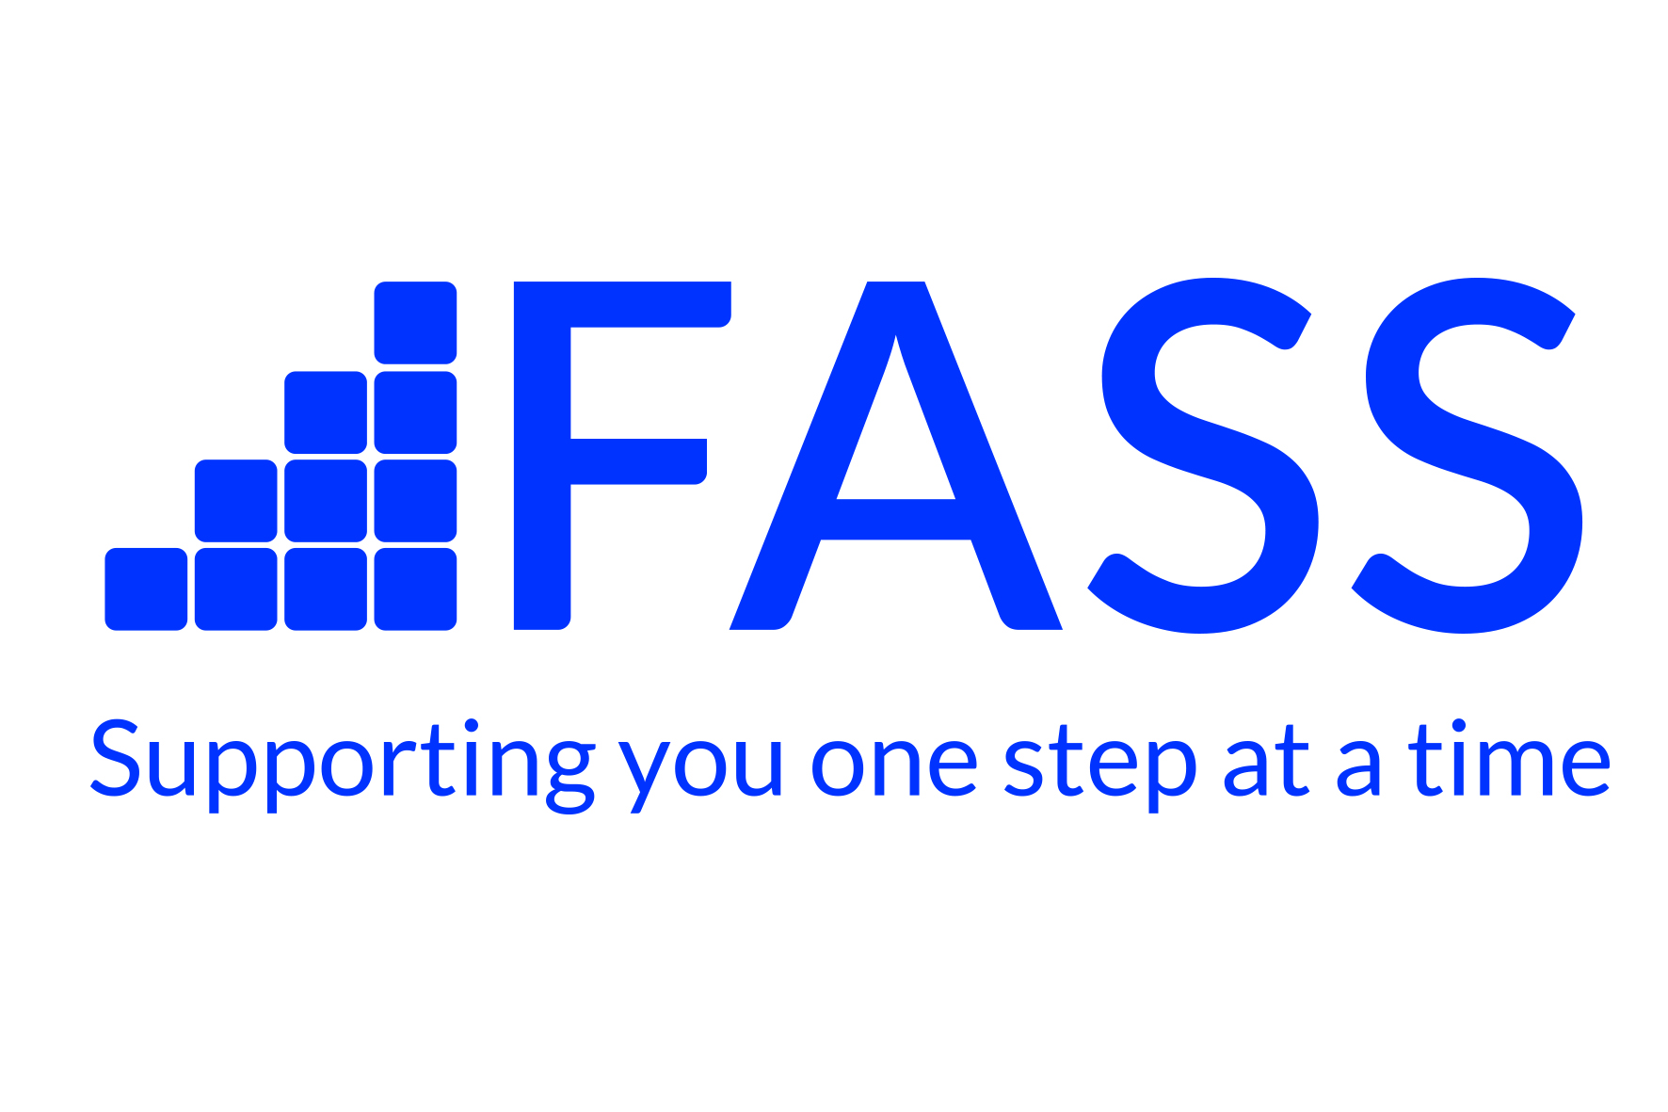

Application Pack
1 x Full Time Positions - £28,061 Per Annum
1x Part Time Position – 21.75hrs (£28,061 – Pro-Rata)
Community Recovery Navigator
Contents:
- Job Description
- Person Specification
- Application Form
- Equal Opportunities Form
- Convictions Disclosure Form
- Data Protection Privacy Notice

Closing Date for Applications: Friday 21st March 2025
Interviews to be held: From Monday 24th March 2025
This post is initially funded until 31st March 2026 and is open to all.
Completed applications should be sent to Dougie.ovenstone@fassaction.org.uk

PERSON SPECIFICATION

ADAPT: Community Recovery Navigator (Adults)

Requirement | Essential or Desirable? | How is this assessed?
Qualifications and Training |  | by application form
A professional qualification at a relevant discipline or equivalent in one or more of the following:  - SVQ  - Nursing  - Mental Health  - Family Work  - Social Care  - Community Education  - Therapeutic Counselling or Psychotherapy | Desirable | by application form
Experience |  | by application form and interview
- Work with patients/clients with complex health and social care needs.  and/or | Essential | by application form and interview
- Therapeutic and/or support work with substance misuse patients/clients  - Experience of basic care for substance using patients/clients, for example:  - Naloxone distribution  - Dry Blood Spot Testing  - Blood Born Virus and Sexual Health  - Harm reduction interventions  - Suicide and self-harm prevention | Desirable | by application form and interview
Skills and Competencies |  | by application form and interview
- Excellent ability to work with substance using patients/clients, their families, and friends in a supportive, empathic, and non-judgement manner.  - Group – work skills & experience  - Excellent networking and communication skills, including telephone, social media, written and verbal. | Essential  Essential | by application form and interview
- Ability to organise and prioritise work, manage time and case workload. | Essential | by application form and interview
- Ability to work within a Multi-Disciplinary Team, take responsibility for agreed areas of work and work on own initiative. | Essential | by application form and interview
- Basic Counselling skills at COSCA Skills Certificate Level 1 or 2 or equivalent, or Motivational Interviewing skills  - Craft – Smart Training.  - Basic IT skills for recording patient/client records | Desirable  Desirable  Essential | by application form and interview
- Ability to work out of hours evening shifts on rotation as required | Essential | by application form and interview
- Ability to travel effectively between service locations throughout Fife. | Essential | by application form and interview



APPLICATION FOR EMPLOYMENT
STRICTLY CONFIDENTIAL

Position applied for | Community Recovery Navigator

How did you first learn of this vacancy?

Identification details
(block letters please)

Surname |  | Initial(s)

Address
 |  |  | Postcode

Contact No(s)

Email

Education and Training
Please list details of your education and professional qualifications, and any relevant training

Qualifications/ Training Grade Attained Date
Fife Alcohol Support Service is a Charity and a Company Limited by Guarantee. Registered in Scotland. Company Registration No. 97502 Registered Charity No. SCO 10422.

Employment History
Please give details of all positions held within the last 10 years, including part-time and unpaid work, starting with your current or most recent employer. Continue on a separate sheet if necessary.

Employer’s full name & address | Job title/  Key achievements & areas of responsibility | Length of time in job/  Reasons for leaving/

Personal Statement
Using criteria section of the person specification, please give a statement in support of your application stating why you want the job, and why your skills and experience demonstrate you are suited for the post. Continue on a separate sheet if necessary.

References
Names and addresses of two referees are required. At least one should be from your present or most recent employer, and should be someone who was employed at a more senior level to yourself. Personal referees will be suitable if you have not been employed previously. (Please note: Relatives are not acceptable as referees.).

Name Name

Position held and relationship to you Position held and relationship to you

Organisation & address Organisation & address

Tel. no Tel. no

Email address Email address
May we contact this referee before interview? May we contact this referee before interview?
Yes No Yes No

Declaration

Are you eligible to work in the UK?
Yes No

The information on this form will be used for recruitment and selection purposes only and all unsuccessful applications will be destroyed twelve months after the closing date.

If it is discovered that you have given any information which you know to be false, or withhold any relevant information your application may be rejected or any subsequent employment terminated.

I confirm that the information contained in this application form is correct.

Signature ….. Date …..…….…………

Please return completed Application to:
Fife Alcohol Support Service
24 Hill Street
Kirkcaldy
KY1 1HZ
Email: Dougie.ovenstone@fassaction.org.uk

Equal Opportunities Form

Fife Alcohol Support Service is committed to the principle of equal opportunities and aims to be an equal opportunities employer. The policy aims to ensure that no job applicant or employee receives less favourable treatment on the grounds of gender, marital status, responsibility for dependants, trade union or political activity or geographic location.

Fife Alcohol Support Service would be grateful for your co-operation to help us ensure that our equal opportunities policy is being carried out satisfactory.

Completion of this form is voluntary and the form will be separated from your application on receipt. If you choose not to complete this form it will not affect treatment of your application. Information you supply will be treated in strictness confidence.

Name _____________________________________________________________________

Post applied for _____________________________________________________________

Gender (please tick) Male □ Female □

Do you consider yourself to have a disability?

Yes □ No □

Please give details if you consider this appropriate.__________________________________

___________________________________________________________________________

Ethnic Origin

White □ Pakistani □ Indian □

Black Caribbean □ Bangladeshi □ Black African □

Black Other □ Chinese □ Other □

Age

16 - 24 □ 25 – 34 □ 35 – 44 □ 45 Upwards □

Thank you for taking the time to complete this form

Convictions Disclosure Form
To be completed for all posts

All employees within FASS have direct access to vulnerable people or access to confidential information about their histories and backgrounds. Furthermore, employees are engaged in employment or work which is concerned with the provision of health services and which is of such a kind as to enable the holder to have access to persons in receipt of such services in the course of their normal duties.

Therefore, all posts within FASS are considered exempt from the Rehabilitation of Offenders Act 1974 (Exclusions and Exceptions) (Scotland) Order 2003 (as amended). This means that all applicants must disclose all previous convictions on their application, even if these would normally be considered as ‘spent’ under the legislation.

A previous conviction will not automatically bar an applicant from employment with the exception of offences against children or other vulnerable groups or those who are considered barred from joining the PVG Scheme, under the Protection of Vulnerable Groups (Scotland) Act 2007.
All successful applicants will be required to become members of the Protecting Vulnerable Groups (PVG) Scheme which is operated via the Government agency DISCLOSURE SCOTLAND. Further information regarding the PVG Scheme is available at www.disclosurescotland.co.uk
In addition, to declaring all previous convictions, FASS requires all applicants to disclose information pertaining to any previous or present charges or investigations. Failure to disclose any conviction/charge or investigation during the selection process will be considered as a breach of trust.
If this situation arises the individual may be summarily dismissed or have any offer of employment withdrawn, irrespective of the nature of the conviction or charges or investigation.
Should an applicant have a conviction or be subject to a charge or investigation or have been charged or investigated in the past, we will make decisions based on careful consideration of all the information available to us. If management feel that further clarification is required, further information may be sought from additional sources, for example, previous employers, placements etc. We may also ask the applicant to supply additional references.
Therefore, we ask that all applicants complete the following sections fully.

Name: _____________________________________

Part 1: Are you currently subject to criminal charges/investigations or have you ever received or been subject to any of the following disposals noted below?

Yes No

If yes, please complete the section below:

Please tick all appropriate boxes
Conviction(s) |  | Warning(s) |  | Reprimand(s)
Caution(s) |  | Charge(s) |  | Admonishment(s)
Procurator Fiscal Fine(s) |  | Dropped Charge(s) |  | Other
When did the incident(s) occur?
What exactly happened?
What was the outcome?
Have you offended since?
Anything else you wish to add / What have you learned from your experience?
Please continue on a separate sheet if required.

Part 2: Have you ever been subject to an investigation or enquiry either within or outwith the workplace into abuse or other inappropriate behaviour? This should include relevant police non-conviction information and any workplace proceedings.
Yes If so, please give details below: No

Part 3: Declaration
I declare that, except for the above disclosed, I have not, whether in the United Kingdom or abroad, been found guilty and sentenced by a court for a criminal offence.

I give my consent to Fife Alcohol Support Service (FASS) to carry out a Protection of Vulnerable Groups Scheme check by Disclosure Scotland and to request references for the purpose of verifying the replies given in this declaration, including enquiries of any relevant authority.

I agree to inform Fife Alcohol Support Service (FASS) if I am convicted of an offence after I take up any post within the organisation. I understand that failure to do so may lead to disciplinary action, which may include termination of my employment.

Signed: |  |  | Date:

For HR Office Use Only
Stage 1: | Read By: |  |  |  |  |  | Date
Any initial action required? For example, discussion at screening interview. If so, please detail below including outcome:
Stage 2: Content checked against Disclosure Scotland?
Yes |  | No
Certificate Number: |  |  |  |  | Date of Issue
Any Action Required? If so, please detail below including outcome:
Name |  |  |  |  |  | Date

Fife Alcohol Support Service

Data protection privacy notice (recruitment)
22nd May 2019

This notice explains what personal data (information) we hold about you, how we collect it, and how we use and may share information about you during your employment and after it ends. We are required to notify you of this information under data protection legislation. Please ensure that you read this notice (sometimes referred to as a ‘privacy notice’) and any other similar notice we may provide to you from time to time when we collect or process personal information about you.

Who collects the information?
Fife Alcohol Support Service is a ‘data controller’ and gathers and uses certain information about you.

Data protection principles
We will comply with the data protection principles when gathering and using personal information, as set out in our Confidentiality Policy.

About the information we collect and hold
The table set out in Part A of the schedule below summarises the information we collect and hold up to and including the shortlisting stage of the recruitment process, how and why we do so, how we use it and with whom it may be shared.
The table in Part B of the schedule below summarises the additional information we collect before making a final decision to recruit, i.e. before making an offer of employment unconditional, how and why we do so, how we use it and with whom it may be shared.
We seek to ensure that our information collection and processing is always proportionate. We will notify you of any changes to information we collect or to the purposes for which we collect and process it.

Where information may be held
Information may be held at our offices and third-party agencies, service providers, representatives and agents as described above.

How long we keep your information.
We keep the personal information that we obtain about you during the recruitment process for no longer than is necessary for the purposes for which it is processed. How long we keep your information will depend on whether your application is successful, and you become employed by us, the nature of the information concerned and the purposes for which it is processed.
We will keep recruitment information (including interview notes) for no longer than is reasonable, taking into account the limitation periods for potential claims such as race or sex discrimination (as extended to take account of early conciliation), after which they will be destroyed. If there is a clear business reason for keeping recruitment records for longer than the recruitment period, we may do so but will first consider whether the records can be pseudonymised, and the longer period for which they will be kept.
If your application is successful, we will keep only the recruitment information that is necessary in relation to your employment. For further information, see FASS – GDPR Privacy Notice Employment.

Further details on our approach to information retention and destruction are available in our Data Retention and Disposal Policy.

Your rights to correct and access your information and to ask for it to be erased
Please contact Jim Bett, Service Manager who can be contacted at jim.bett@fassaction.org.uk or on 01592 206200 if (in accordance with applicable law) you would like to correct or request access to information that we hold relating to you or if you have any questions about this notice. You also have the right to ask our Service Manager for some but not all of the information we hold and process to be erased (the ‘right to be forgotten’) in certain circumstances. Our Service Manager will provide you with further information about the right to be forgotten, if you ask for it.

Keeping your personal information secure
We have appropriate security measures in place to prevent personal information from being accidentally lost or used or accessed in an unauthorised way. We limit access to your personal information to those who have a genuine business need to know it. Those processing your information will do so only in an authorised manner and are subject to a duty of confidentiality.
We also have procedures in place to deal with any suspected data security breach. We will notify you and any applicable regulator of a suspected data security breach where we are legally required to do so.

How to complain
We hope that the Service Manager can resolve any query or concern you raise about our use of your information. If not, contact the Information Commissioner at ico.org.uk/concerns/ or telephone: 0303 123 1113 for further information about your rights and how to make a formal complaint.

About the information we collect and hold
Part A
Up to and including the shortlisting stage
The information we collect | How we collect the information | Why we collect the information | How we use and may share the information
Your name and contact details (i.e. address, home and mobile phone numbers, email address) | From you | Legitimate interest: to carry out a fair recruitment process  Legitimate interest: to progress your application, arrange interviews and inform you of the outcome at all stages | To enable HR personnel or the manager of the relevant department to contact you to progress your application, arrange interviews and inform you of the outcome  To inform the relevant manager or department of your application
Details of your qualifications, experience, employment history (including job titles and working hours) and interests | From you, in the completed application form and interview notes (if relevant) | Legitimate interest: to carry out a fair recruitment process  Legitimate interest: to make an informed decision to shortlist for interview and (if relevant) to recruit | To make an informed recruitment decision  The person(s) making the shortlisting decision will receive pseudonymised or anonymised details only; if you are invited for interview, the interviewer will receive non-anonymised details
Your racial or ethnic origin, sex and sexual orientation, religious or similar beliefs | From you, in a completed anonymised equal opportunities monitoring form | To comply with our legal obligations and for reasons of substantial public interest (equality of opportunity or treatment) | To comply with our equal opportunities monitoring obligations and to follow our equality and other policies  For further information, see * below
Information regarding your criminal record | From you, in your completed application form | To comply with our legal obligations  For reasons of substantial public interest (preventing or detecting unlawful acts, suspicion of terrorist financing or money laundering in the regulated sector and protecting the public against dishonesty) | To make an informed recruitment decision  To carry out statutory checks  Information shared with PVG and other regulatory authorities as required  For further information, see ** below
Details of your referees | From your completed application form | Legitimate interest: to carry out a fair recruitment process  In the regulated sector, to comply with our legal obligations to obtain regulatory references | To carry out a fair recruitment process  To comply with legal/regulatory obligations  Information shared with relevant managers, HR personnel and the referee
Part B
Before making a final decision to recruit
The information we collect | How we collect the information | Why we collect the information | How we use and may share the information
Information about your previous academic and/or employment history, including details of any conduct, grievance or performance issues, appraisals, time and attendance, from references obtained about you from previous employers and/or education providers ☐ | From your referees (details of whom you will have provided) | Legitimate interest: to make an informed decision to recruit  To comply with our legal obligations  Legitimate interests: to maintain employment records and to comply with legal, regulatory and corporate governance obligations and good employment practice | To obtain the relevant reference about you  To comply with legal/regulatory obligations  Information shared with relevant managers and HR personnel
Information regarding your academic and professional qualifications ☐ | From you, from your education provider, from the relevant professional body | Legitimate interest: to verify the qualifications information provided by you | To make an informed recruitment decision
Information regarding your criminal record, including that from Disclosure Scotland and Protection of Vulnerable Groups (PVG) ☐ | From you and Volunteer Scotland Disclosure Services (administrators of PVG), from Disclosure Scotland or the Disclosure and Barring Service (DBS) | To perform the employment contract  To comply with our legal obligations  Legitimate interest: to verify the criminal records information provided by you  For reasons of substantial public interest (preventing or detecting unlawful acts, suspicion of terrorist financing or money laundering in the regulated sector and protecting the public against dishonesty) | To make an informed recruitment decision  To carry out statutory checks  Information shared with Volunteer Scotland Disclosure Services and other regulatory authorities as required  For further information, see ** below
Your nationality and immigration status and information from related documents, such as your passport or other identification and immigration information ☐ | From you and, where necessary, the Home Office | To enter into/perform the employment contract  To comply with our legal obligations  Legitimate interest: to maintain employment records | To carry out right to work checks  Information may be shared with the Home Office
A copy of your driving licence ☐ | From you | To enter into/perform the employment contract  To comply with our legal obligations  To comply with the terms of our insurance | To make an informed recruitment decision  To ensure that you have a clean driving licence  Information may be shared with our insurer

*You are required (by law or in order to enter into your contract of employment) to provide the categories of information marked ‘☐’ above to us to enable us to verify your right to work and suitability for the position.
**Further details on how we handle sensitive personal information and information relating to criminal convictions and offences are set out in our Recruitment Policy, PVG Secure Handling Policy, PVG Barred and Under Consideration for Listing Policy, PVG Referrals Policy and Recruitment of Ex-Offenders Policy. These are available from the FASS Office at 17 Tolbooth Street, Kirkcaldy KY1 1RW.

