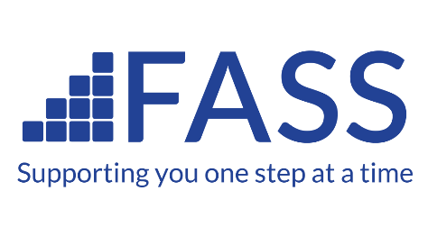

APPLICATION FOR THE POSITION OF TRUSTEE VOLUNTEER WITH FIFE ALCOHOL SUPPORT SERVICE (FASS)

This role is unpaid, although reasonable personal expenses can be reimbursed.
We ask that applicants are able to dedicate 8 hours per month on average to this role.

About FASS
FASS improves the quality of life of people in Fife who are affected by substance misuse or adverse health & social well-being. Our Fife-wide services provide information and early intervention, psycho-social counselling, and recovery support for individuals and families.
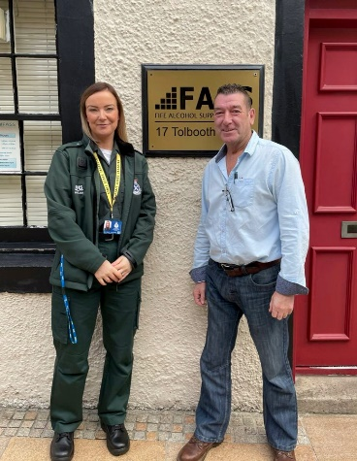
Alongside our Alcohol Counselling, Community Drug and ADAPT Triage services, our Near Fatal Overdose (NFO) team are reducing drug deaths in Fife; our Curnie Clubs are helping isolated adults into community activity of their choice; and our FASD (Fetal Alcohol Spectrum Disorder) Fife project is the only local support service of its kind in Scotland.
All of our services are client-centred and based on evidence of effectiveness and models of good practice. They focus on finding solutions. We help people achieve personal-strengths based recovery. Clients are enabled to identify, build and utilize their own resources within a therapeutic environment that is non-judgemental, empathic and supportive.
FASS is also active in the community, informing and educating about the scale and impact of alcohol and substance misuse. We promote research and provide training on prevention, early diagnosis and treatment, and sustainable recovery from substance misuse; as well as Mental Health First Aid and Suicide Prevention.
Managers of Scottish Ambulance and our NFO services discussing partnership work
Our alcohol and substance misuse services are delivered in accordance with the Scottish Government's 'The Quality Principles: Standard Expectations of Care and Support in Drug and Alcohol Services', and we are a COSCA Recognized organisation. We work in partnership with all of Fife’s relevant statutory and charity organisations.
Please visit our website for more information on our work and services: https://www.fassaction.org.uk/

The Trustee Role

As a FASS Trustee you will oversee the work of the FASS Management Team, who are responsible for the day to day operations of the charity. You will be collaborating with other Trustees with specialisms such as finance, business, health, local government and others. As Trustees, you will meet with the Management Team in our Executive Committee meetings around six times per year. Ideally you will be able to attend Executive Committee Meetings in person, however, we are still interested in hearing from you if you must, occasionally, join digitally. Occasional Board-only meetings may also be required, or you may be asked, or wish, to volunteer your expertise as part of a working group on a specific developmental task.

ROLE DESCRIPTION

Position: Trustee/Director (Volunteer)

MAIN RESPONSIBILITIES

- Ensure that Fife Alcohol Support Service (FASS), a Charity registered in Scotland and a Company Limited by Guarantee complies with its constitution, charity law, company law and any other relevant legislation or regulations.
- Ensure that the Charity complies with its objects as defined in its constitution, which includes provision of therapeutic services involving regulated work with protected adults.
- Ensure the Charity uses its resources exclusively in pursuance of its objects: the Charity must not spend money on activities which are not included in its own objects, no matter how worthwhile or charitable those activities are.
- Contribute actively to the FASS Executive Committee’s (Board of Trustee/Directors) role in giving firm strategic direction to the Charity, setting overall policy, defining goals, setting targets, and evaluating performance against agreed targets.
- Safeguard the good name and values of the Charity.
- Ensure the effective and efficient administration of the Charity.
- Ensure the financial stability of the Charity.
- Protect and manage the property of the Charity and to ensure the proper investment of the Charity's funds.

Other responsibilities

In addition to the above responsibilities, each Trustee/Director should use any specific skills, knowledge or experience they have to help the Executive Committee reach sound decisions. This may involve:
- Scrutinising board papers
- Leading discussions
- Focusing on key issues
- Providing guidance on new initiatives
- Commitment to the Company
- Willingness to devote the necessary time and effort
- Other issues in which the trustee has special expertise

PERSON SPECIFICATION

- Strategic vision
- Good, independent judgement
- Ability to think creatively
- Willingness to speak their mind
- Understanding and acceptance of the legal duties, responsibilities and liabilities of trusteeship
- Ability to work effectively as a member of a team
- Nolan's seven principles of public life: selflessness, integrity, objectivity, accountability, openness, honesty and leadership.

For more detailed information on Charity Trustee duties please visit the Office of the Scottish Charity Regulator (OSCR) OSCR | Trustee Duties

HOW TO APPLY

- Please send your CV and a brief introductory letter to mhairi.owens@fassaction.org.uk
- The closing date for applications is 22nd April 2022
- Informal interviews will be held in May.

We look forward to hearing from you.

